Regulatory Framework and Tax Benefits - FORESTRY SECTOR
Uruguay has an adequate regulatory framework that benefits investors. Some regulations are of a general nature for all sectors and others are specific to the forestry sector.

General Investment Promotion Regime (Law 16,906)
The main investment promotion regime is framed under Law Nº 16,906, which declares of national interest the promotion and protection of investments made by domestic and foreign investors in national territory. The Law is regulated by a number of decrees and classifies tax incentives into two groups: general incentives for investment and incentives for specific investments.

The general investment promotion regime has undergone some recent modifications that make it even more advantageous. The following are the main benefits under Decree 268/020 for investment projects submitted to COMAP:

- IRAE (Income Tax on Economic Activities) exemptions: from 30% to 100% of the investment for a minimum period of four years and a maximum of 25 years, depending on the amount invested and the score obtained in six indicators (or in the simplified employment matrix):

- Employment
- Exports
- Decentralization
- Cleaner technologies
- Incorporation of R&D
- Sector indicator

- The IRAE exemption may reach up to 90% of the tax payable in each fiscal year included in the promotional tax declaration, so the minimum effective IRAE rate is 2.5%.

- The exemption period may be suspended for up to two consecutive fiscal years or not.

- VAT refund for the local purchase of materials and services for civil works and personal property for the investment project.

- Wealth Tax exemptions:

  - On civil works for eight years in Montevideo and for ten years in the Interior of the country.
  - On movable fixed assets included in the eligible investment for their entire useful life.

- Exemptions from import duties or taxes, including VAT on movable fixed assets and materials for civil works, which are declared non-competitive with domestic industry.

Eligible Investment
- Movable property destined to the activity of the company with a minimum total value per item purchased of 500 UI (Indexed Units). Property intended for household use, vehicles acquired to be leased by companies whose activity is leasing vehicles without a driver (except electric passenger vehicles) and non-utility vehicles are excluded.
- Used goods purchased locally, directly or indirectly involved in the production process, will be eligible, provided that they have never been subject to tax benefits before, and they are not older than 3 years from the date of first purchase in the country.
- In the case of investments in renewable energies—photovoltaic solar panels—, those that account for up to 20% of the total investment project submitted will be eligible and must also score at least 2 weighted points in the Employment Generation indicator.
- The construction of properties or fixed improvements in self-owned properties, excluding those destined for housing and fixed improvements in properties owned by third parties, provided that there is a contract with a minimum remaining term of three years.
- Seedlings and the costs of planting multi-annual fruit trees and shrubs.
- Passenger vehicles with electric motor (until August 31, 2023).
- Intangible assets as defined by the Executive Power.
Investment Term
    - The eligible investment may be made up to six months prior to filing the application and within the following ten years.

Approval Term
    - COMAP has 90 working days to make the recommendation to the Executive Power. If upon expiration of this term, COMAP has not issued a decision, it will be deemed as an implied recommendation to the Executive Power.

INDUSTRIAL PARKS
There are currently eight industrial parks in operation in Uruguay:
- Parque Industrial de Juan Lacaze
- Parque Industrial Paysandú
- Parque Productivo Uruguay
- Parque Tecnológico Industrial del Cerro
- Plaza Industrial S.A. “Zona Este”
- Parque Industrial de Pando
- Parque Industrial y Logístico Ruta 5
- Parque Científico Tecnológico de Pando

There is an additional IRAE exemption benefit of 15% (in exemption and term) over the percentage obtained by COMAP for those industrial park users that carry out any of the following activities:
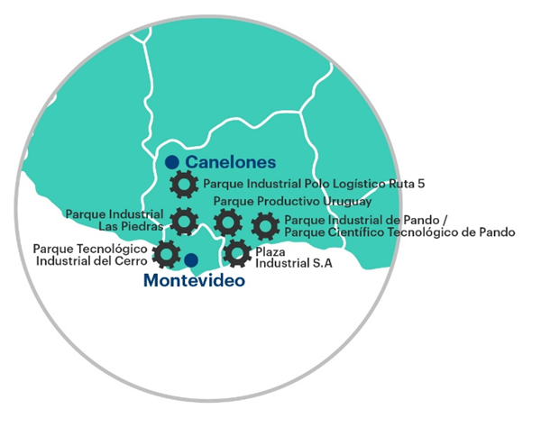
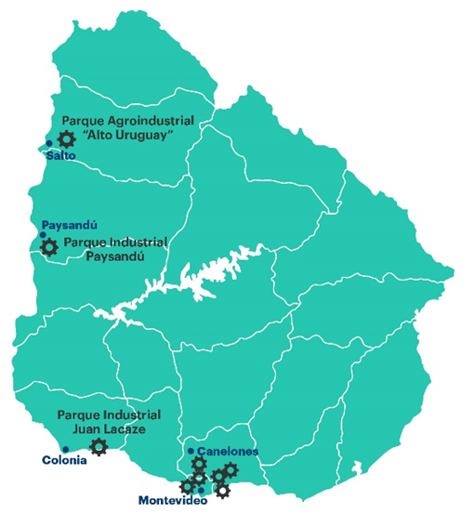

- Industrial activities.
- Provision of services such as storage, conditioning, selection, classification, fractioning, assembling, disassembling, handling or mixing of merchandise or raw materials, related to the activities developed in the park. The term “related” shall be understood as that service belonging to the industrial value chain.
- Solar thermal and/or photovoltaic energy generation activities under the promotional measures of the Executive Power in force at the time of submitting the project, decrees, ministerial resolutions and/or contracts with the state-owned energy company UTE.
- Waste recovery and utilization activities.
- Service activities in the areas of information and communication technologies, biotechnology and creative industries given their potential for contributing to the objectives established in Article 1 of Law Nº 19,784.

In the case of other users, they may receive an additional 5% IRAE exemption benefit.
In addition, those who carry out activities included in items a and b, will have a tax credit for the employer's pension fund contributions during the compliance scheme period for the employment indicator (five years).

Forestry Law (Nº 15,939)
Plantations and other activities related to forestry are regulated by Law Nº 15,939 of 1987 (“Forestry Law”), regulatory decrees and subsequent amendments. This law declares of national interest the defense, improvement, expansion and creation of forest resources, the development of forestry industries and, in general, of the forestry economy. This regulation establishes that natural and artificial forests in forest priority zones declared as “protective” and forests declared as “yield included in the quality wood projects defined by the Ministry of Livestock, Agriculture and Fisheries (MGAP), will enjoy the following tax benefits:
- Income derived from its exploitation is not considered for IRAE purposes.
- Their respective values or extensions are not considered for the calculation of the Wealth Tax taxable amount.
- Exemption from the Rural Real Estate Tax (land property tax).

In order to access the aforementioned tax benefits, the General Forestry Directorate of the Ministry of Livestock, Agriculture and Fisheries must approve the management and planning project for the exploitation and regeneration of forests. Any modification to said management plan must be previously approved by the General Forestry Directorate. It should be noted that short rotation plantations (less than fifteen years) without pruning and thinning management are not tax exempt.
Likewise, Decree 002/012 considers the purchase of seedlings and the cost of planting multiannual fruit trees and shrubs as part of the investment in promoted activities.
Regulations: Law Nº 15,939, Law Nº 18,245, Title 4 of Consolidated Text, Law Nº 18,083 and Regulatory Decrees.

General Export Incentives
TEMPORARY ADMISSION
Temporary Admission allows the introduction of foreign goods from outside the national customs territory, free of taxes, for a specific purpose other than consumption (on a non-permanent basis) to be re-dispatched within a certain period of time, either on an “as is” basis or after having undergone a certain transformation, processing, repair or value addition, with effective employment of labor.
Manufacturing companies can introduce duty-free raw materials and intermediate inputs for the product to be exported.
Machines and equipment of any origin, which enter temporarily for repair, maintenance, updating or use, are also covered by this regime.
EXPORT TAX REFUNDS
In the case of production and export activities, an export tax refund may be obtained (to be combined with temporary admission), depending on the product’s tariff classification. It can range from 3% to 6% of the FOB value exported. The benefit can be obtained by proving that the product reaches 20% of the National Added Value. Wood products in general benefit from a 6% refund.
REFUND OF VAT PAID ON INPUT PURCHASES
For non-exporting companies, VAT paid on purchases is recovered by deducting it from the VAT invoiced on sales made within the national territory, paying the State only the difference. In the case of exports (of goods and services) the tax is not invoiced, so the VAT included in the purchase of inputs is refunded directly at the company's request. The Tax Authority (DGI) issues credit certificates that may be used to pay other taxes.

Free Trade Zone Regime
Free trade zones are areas determined by the Executive Power where all types of industrial, commercial and service activities may be developed, without any limitation whatsoever and with total exemption of all domestic taxes created or to be created. Likewise, the introduction of goods to the premises is exempted from all taxes. The exemption does not include the social security contributions of Uruguayan staff. The State, by legal mandate, became the guarantor of the rights granted by law to users, being responsible for damages, to ensure the observance of said rights.
The current regime is governed by Law Nº 19,566 since December 2017. Previously, it was governed by Law Nº 15,921 with amendments introduced by Article 65 of Law Nº 17,292, Article 23 of Law Nº 17,781 and indirectly by Law Nº 18,083.
There are three types of subjects that companies may adopt in relation to free trade zones: operators, direct users, and customers.
- Free Trade Zone Operators
An operator is the individual or legal entity that provides the necessary and sufficient infrastructure for the establishment and operation of a free trade zone. Free trade zones may be operated by the State or by duly authorized private individuals. Private free trade zones are administered by individuals and authorized by the Ministry of Economy and Finance, which supervises and controls them through the Free Trade Zone Area of the General Directorate of Commerce. For the installation of a free trade zone in Uruguay, a governmental resolution is required, detailing information such as: period of authorization of operation, area occupied by the free trade zone, minimum investment to be made by the operator(s) and the fee to be paid by the operator(s), among others.
They can take advantage of the benefits of the Investment Law.
- Free Trade Zone Users
The direct user is the one who contracts with the operator in exchange for a price freely agreed with the latter and is granted the right to operate in a free trade zone.
The indirect user is the one who contracts, no longer with the operator, but with the direct user in exchange for a price agreed by the latter, obtaining as consideration the right to operate in the free trade zone, using its facilities, for instance, making use of its warehouses.
Free trade zones are conceived so that companies that want to take advantage of the benefits of being users can develop any type of export-oriented activity, such as:
- Commercialization, storage, conditioning, classification, fractioning, mixing, assembling, disassembling and other operations not implying the industrialization of goods and raw materials.
- Installation and operation of manufacturing facilities.
- Rendering of all kinds of services, including professional, financial, computer, repair, and maintenance services.

The following are limitations to this broad range of activities:
No primary activities (agricultural, extractive, etc.), retail sales or free entry to the non-free territory of goods deposited or industrialized in the free trade zone shall be permitted.
Sales from the rest of the country to the free trade zones are considered exports from Uruguay and sales from the free trade zones to the rest of the Uruguayan territory are considered imports, subject to the corresponding customs duties and domestic taxes.
Sales from free trade zones to Mercosur are subject to the bloc's Common External Tariff (CET), which applies to goods from third countries. This is because goods from free trade zones do not have preferential access, according to Decision Nº 8/994 of the Common Market Council. Uruguay has agreements with Argentina and Brazil for certain products from the free trade zones of Colonia and Nueva Palmira (including goods produced by PepsiCo, wheat, barley, barley malt, and soybeans). Sales from free trade zones are also included in trade agreements with Chile, Israel, Mexico, India, Ecuador, Venezuela, and Colombia.
Free trade zone users may also provide services within the rest of the national territory to companies that are IRAE taxpayers and other types of services such as call centers, mailboxes, among others.
It is possible to buy and sell goods that enter the free trade zone with origin and destination in the national territory.
The main activity of the free trade zone user must be developed in the free trade zone. Notwithstanding the foregoing, the law authorizes the collection of delinquent accounts receivable through third parties and exhibition of goods in non-free trade zone territory, in this case, only for companies with possible location disadvantages.
With the authorization of the Executive Power, the development of complementary activities to the non-free trade territory is permitted. Likewise, it is contemplated that the users of free trade zones outside the metropolitan area may develop activities outside the same, in administrative offices provided by free trade zone developers, as long as these are complementary in nature to the main activity.
The activities of free trade zone users are exempt from all domestic taxes, created or to be created; in particular, they have the following benefits:
- Exemption from Income Tax on Economic Activities (IRAE), Wealth Tax (IP), and any other domestic tax.
- Tax exemption for dividends paid to shareholders with residence abroad.
- Option for foreign staff (up to 25% of the total employed) not to pay social security contributions in Uruguay.
- Sales and purchases abroad of goods and services are not subject to VAT, nor are sales and services rendered within the free trade zone.
- The goods exchanged between the free trade zones and the rest of the world are exempt from customs duties.
The requirements to be a free trade zone user are as follows:
Regarding contract terms, for industrial companies the maximum term for direct user contract authorizations is set at 15 years, while for service or commercial companies it is set at 10 years. For indirect users, the maximum term is five years for any type of activity. Automatic extensions are not authorized.
- Free Trade Zone Customers
In the free trade zone operation, there is also the customer or depositary, which is the one that contracts, both with the direct user and indirect user, the right to deposit certain merchandise in its warehouses.
Regulations: Law Nº 15,921, Law Nº 16,906, Law Nº 17,547, Decree Nº 524/005.
In the case of the forestry sector, two free trade zones were created for the benefit of the two pulp mills installed in the country, UPM and Montes del Plata, and it is also planned for UPM2.

Other Relevant Regulations to the Forestry Sector
- Decree 372/99: Regulation on working conditions in the forestry sector.
- Environmental Impact Assessment Law (Nº 16,466) and decrees (435/94 and 349/05).
- Decree 848/988: Fire prevention.

Commission on the Application of the Investment Law. See documents required to draw up and submit a project.
A minimum of one point must be obtained among all indicators (except decentralization). See indicator guide.
As of March 28, 2022, it is equivalent to US$63 (UI=$5.30; Exchange Rate=$41.79).
For more information, see Decree Nº 268/020, page 3. The CIF value of utility vehicles, pick-up trucks and vans shall not exceed US$30,000. In the case of electric vehicles this shall not exceed US$60,000.
For more information, see Art. 23 of Decree Nº 268/020, page 14.
For more information, please see the report on industrial parks of Uruguay XXI.
Law Nº 15,939 is available at: https://parlamento.gub.uy.
Decree Nº 220/998 lists the operations included in the item “exports of services”.
For more information on the free trade zone regime, see: Free Trade Zones in Uruguay – Uruguay XXI.
Website: http://www.zfrancas.gub.uy/.
The agreement with Argentina only covers the Colonia free trade zone.
Monopolies, state exclusivities or public concessions must be respected. Services rendered to the rest of the national territory will receive the same tax treatment as services rendered from abroad.
Excluding those whose only or main destination is the rest of the national territory.
Complementary activities: public relations, handling of ancillary documents, invoicing and collection of goods and services. In no case shall sales operations of goods and services be permitted.
In justified cases, the percentage may be increased with prior government authorization.

